JS-Control flows

**Date: 18-05-2024**

<body>

    <script src="controlFlow.js"></script>

</body>

1. Write a program to check eligible to vote. (eligible to vote if age 18+)
   * age = 24;
   * **Display message: "You are eligible to vote"**

// Question 01

var votingAge = 18;

if (votingAge < 24) {

    console.log("You are eligible to vote");

}

1. Write a program to check whether a given number is even or odd.
   * num = 27;
   * **Display message: "Number {num} is odd/ even"**

// Question 02

const number = prompt("Enter a number: ")

if (number % 2 == 0) {

    console.log("The number is even");

}

else {

    console.log("The number is odd");

}

1. Write a program that displays the largest integer among two integers.
   * num1 = 10;
   * num2 = 2;
   * **Display message: "{num1} is large than {num2}"**

// Question 03

const number1 = prompt("Enter number 1: ")

const number2 = prompt("Enter number 2: ")

if (number1 > number2) {

    console.log("{num1} is large than {num2");

}

else {

    console.log("{num2} is large than {num1");

}

1. Write a program that determines if a year is a leap year.
   * year = 2024;
   * **Display message: "{year} is leap year"**

// Question 04

function isLeapYear(year) {

    return (year % 4 === 0 && year % 100 !== 0) || (year % 400 === 0);

}

const year = 2024;

if (isLeapYear(year)) {

    console.log(`${year} is a leap year`);

} else {

    console.log(`${year} is not a leap year`);

}

1. Write a program to check alphabet it is vowel or consonant using switch case.
   * alphabet = 'a';
   * **Display message: "{alphabet } is vowel/ consonant"**

// Question 05

let alphabet  = 'a';

switch (alphabet) {

    case 'a':

    case 'e':

    case 'i':

    case 'o':

    case 'u':

    case 'A':

    case 'E':

    case 'I':

    case 'O':

    case 'U':

        console.log(alphabet + " is vowel");

        break;

        console.log(alphabet + " is consonant");

}

1. Write a program to compute the sum of the first 10 natural numbers using a **for** loop.
   * **Display message: "The first {number} number's sum is {sum}."**

// Question 06

let sum = 0;

for (let i = 1; i <= 10; i++) {

    sum += i;

}

console.log(`The first 10 numbers' sum is ${sum}.`);

1. Write a program to print given shapes.
   * **For loop**

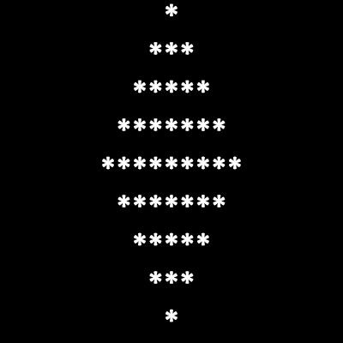

// Question 07

function printShape(size) {

    let middle = Math.ceil(size / 2);

    let spaces = middle - 1;

    let stars = 1;

    for (let i = 1; i <= middle; i++) {

        console.log(" ".repeat(spaces) + "*".repeat(stars));

        spaces--;

        stars += 2;

    }

    spaces = 1;

    stars = size - 2;

    for (let i = middle + 1; i <= size; i++) {

        console.log(" ".repeat(spaces) + "*".repeat(stars));

        spaces++;

        stars -= 2;

    }

}

printShape(7);

* + 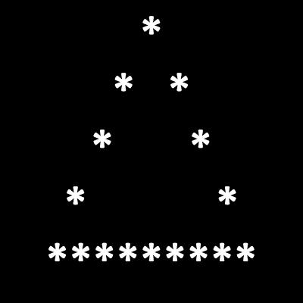**while loop**

// Question 08

function printShape() {

    let height = 5;

    let width = height * 2 - 1;

    let row = 1;

    while (row <= height) {

        let spaces = height - row;

        let stars = (row === height) ? width : (row * 2 - 1);

        let line = '';

        for (let i = 0; i < spaces; i++) {

            line += ' ';

        }

        for (let i = 0; i < stars; i++) {

            if (i === 0 || i === stars - 1 || row === height) {

                line += '*';

            } else {

                line += ' ';

            }

        }

        console.log(line);

        row++;

    }

}

printShape();